What Your Klout Score Really Means
- By Seth Stevenson
- Email Author
- 04.24.12 7:32 PM
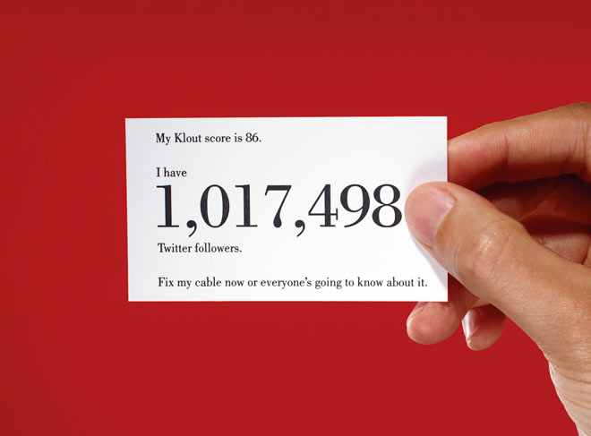
Photo: Garry McLeod
Last spring Sam Fiorella was recruited for a VP position at a large Toronto marketing agency. With 15 years of experience consulting for major brands like AOL, Ford, and Kraft, Fiorella felt confident in his qualifications. But midway through the interview, he was caught off guard when his interviewer asked him for his Klout score. Fiorella hesitated awkwardly before confessing that he had no idea what a Klout score was.

Also in this issue
- The Man Who Makes the Future
- How to Spot the Future
- The Rise of the Robot Reporter
The interviewer pulled up the web page for Klout.com—a service that purports to measure users’ online influence on a scale from 1 to 100—and angled the monitor so that Fiorella could see the humbling result for himself: His score was 34. “He cut the interview short pretty soon after that,” Fiorella says. Later he learned that he’d been eliminated as a candidate specifically because his Klout score was too low. “They hired a guy whose score was 67.”
Partly intrigued, partly scared, Fiorella spent the next six months working feverishly to boost his Klout score, eventually hitting 72. As his score rose, so did the number of job offers and speaking invitations he received. “Fifteen years of accomplishments weren’t as important as that score,” he says.
Much as Google’s search engine attempts to rank the relevance of every web page, Klout—a three-year-old startup based in San Francisco—is on a mission to rank the influence of every person online. Its algorithms comb through social media data: If you have a public account with Twitter, which makes updates available for anyone to read, you have a Klout score, whether you know it or not (unless you actively opt out on Klout’s website). You can supplement that score by letting Klout link to harder-to-access accounts, like those on Google+, Facebook, or LinkedIn. The scores are calculated using variables that can include number of followers, frequency of updates, the Klout scores of your friends and followers, and the number of likes, retweets, and shares that your updates receive. High-scoring Klout users can qualify for Klout Perks, free goodies from companies hoping to garner some influential praise.
But even if you have no idea what your Klout score is, there’s a chance that it’s already affecting your life. At the Palms Casino Resort in Las Vegas last summer, clerks surreptitiously looked up guests’ Klout scores as they checked in. Some high scorers received instant room upgrades, sometimes without even being told why. According to Greg Cannon, the Palms’ former director of ecommerce, the initiative stirred up tremendous online buzz. He says that before its Klout experiment, the Palms had only the 17th-largest social-networking following among Las Vegas-based hotel-casinos. Afterward, it jumped up to third on Facebook and has one of the highest Klout scores among its peers.
Klout is starting to infiltrate more and more of our everyday transactions. In February, the enterprise-software giant Salesforce.com introduced a service that lets companies monitor the Klout scores of customers who tweet compliments and complaints; those with the highest scores will presumably get swifter, friendlier attention from customer service reps. In March, luxury shopping site Gilt Groupe began offering discounts proportional to a customer’s Klout score.
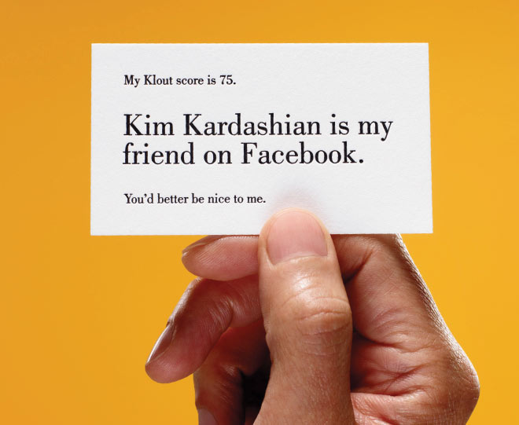
Photo: Garry McLeod
Matt Thomson, Klout’s VP of platform, says that a number of major companies—airlines, big-box retailers, hospitality brands—are discussing how best to use Klout scores. Soon, he predicts, people with formidable Klout will board planes earlier, get free access to VIP airport lounges, stay in better hotel rooms, and receive deep discounts from retail stores and flash-sale outlets. “We say to brands that these are the people they should pay attention to most,” Thomson says. “How they want to do it is up to them.”
Not everyone is thrilled by the thought of a startup using a mysterious, proprietary algorithm to determine what kind of service, shopping discounts, or even job offers we might receive. The web teems with resentful blog posts about Klout, with titles like “Klout Has Gone Too Far,” “Why Your Klout Score Is Meaningless,” and “Delete Your Klout Profile Now!” Jaron Lanier, the social media skeptic and author of You Are Not a Gadget, hates the idea of Klout. “People’s lives are being run by stupid algorithms more and more,” Lanier says. “The only ones who escape it are the ones who avoid playing the game at all.” Peak outrage was achieved on October 26, when the company tweaked its algorithm and many people’s scores suddenly plummeted. To some, the jarring change made the whole concept of Klout seem capricious and meaningless, and they expressed their outrage in tweets, blog posts, and comments on the Klout website. “Not exactly fun having the Internet want to punch me in the face,” tweeted Klout CEO Joe Fernandez amid the uproar.
But not everyone wants to clock Fernandez. In fact, he appears to be at the forefront of a new and extremely promising online industry. Klout has received funding (a rumored $30 million of it) from venture capital behemoths like Kleiner Perkins Caufield & Byers and Venrock. It’s facing down competitors like Kred and PeerIndex, racing to establish something akin to the Nielsen ratings for online social interactions. Klout may be ridiculed by those who find it obnoxious or silly or both, but it is aiming to become one of the pillars of social media.
Tags: Klout
- Post Comment |
- 228 Comments and 5935 Reactions |
- Permalink

